**Off Notification while pushing data via API In Bigcommerce**

Note : Be careful before migrate data

Off all notification from bigcommerce

1. Go to => Advanced Settings

See below image:-

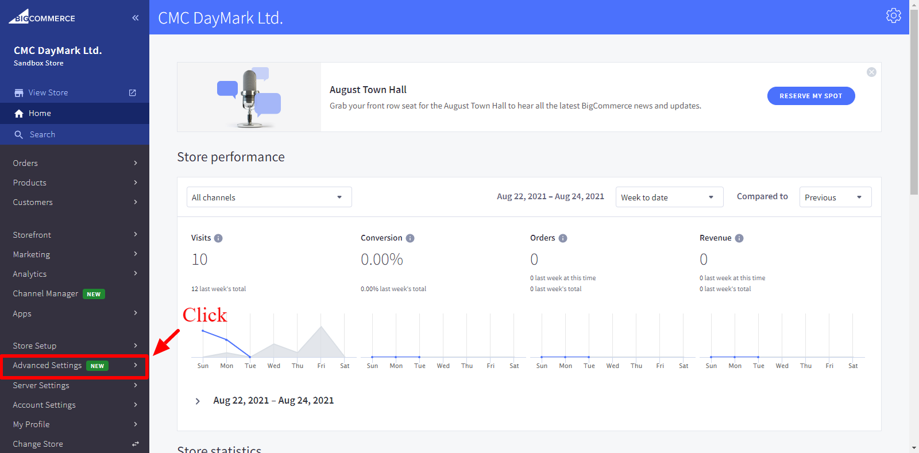

1. Click on => Order Notifications

Now , **Uncheck** all notifications in **Email customers when** and save.

